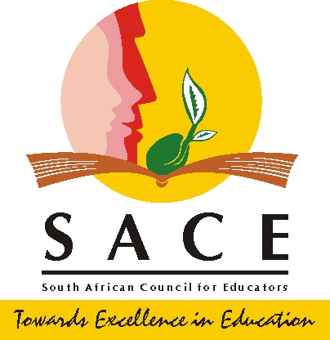

MEDIA STATEMENT

14 March 2023

BOGUS “TEACHER” ARRESTED AT SACE HEADQUARTERS

A bogus “teacher” was arrested at the South African Council for Educators (SACE) headquarters in Centurion Gauteng province for presenting a fake qualification on Tuesday, March 14.

A 26 years male from North West Province was arrested by the Lyttleton police with a fake UNISA Bachelor of Education (BED) degree.
According to SACE registration manager Tebogo Mokgoloboto, this is the third arrest in two months after two “bogus” teachers were arrested with fake qualifications at the same premises.

Council warns people who have fake qualifications or in the process if getting one to never come anywhere near SACE premises or schools because there are measures in place and they will be arrested on the spot.

According to the police the man was charged with submission of fraudulent qualifications and is set to appear in court soon.

For further communication, please contact:
Mr Risuna Nkuna
Tel: 069 423 7490 / Email : Risuna.Nkuna@sace.org.za
Issue date : 14 March 2023

